**Music at the Conley**

It's been an exciting couple of weeks in music class!  Today we were visited by guest artist George Lernis, a World Percussionist and Conley community member!George shared with us some drums and rhythms from Greece and Turkey!  In preparation for George's visit, we have been listening to music from Turkey and Greece and exploring some mosaic art that is found there.  Here are some pictures from today's performance, and some mosaics created by Conley students. A BIG thank you to George Lernis for sharing his amazing expertise with the Conley Community!If you have any questions about the music curriculum, or if you would like more information about you child's progress in music class, please don't hesitate to contact me by phone or email!

Warmly, Ms. Russell

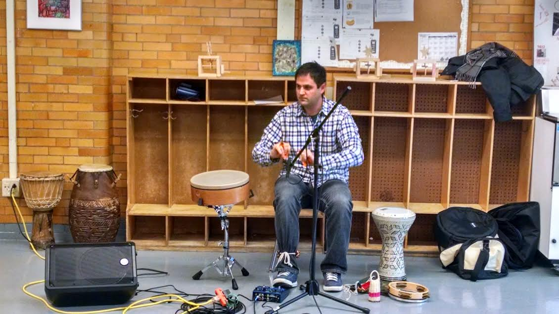

**Jingle Bell Shop Sale: Friday, 12/15**

The Jingle Shop is our annual holiday sale for students to shop and buy small items for friends and families. We are hosting another Jingle Bell Shop sale Thursday 12/15! We are still looking for gently used or new items to donate to the sale! We are also looking for tape and labels! Please drop off all items to the office! Thank you in advance for your support.

**Winter has arrived!!**

As we enter the winter months please be sure that your child comes to school wearing a winter coat, hat, and gloves/mittens. We will do our best to allow students to go outside for PE and recess. Each day Mr. Foley and Nurse Sandy refer to the “Child Care Weather Watch” to determine if we can allow students outside. If you have any questions please let us know. If you need any support in getting your child a winter coat, please contact Mr. Foley.

**Our Instructional Focus**

***As educators we will collaboratively plan and scaffold lessons to ensure access to Cognitively Demanding Tasks (CDTs) for ALL students as demonstrated through their speaking and listening skills and student work.***

**PARCC Question of the Week**

Each week we will provide a PARCC question. All students in grades 3 – 5 are required to answer our PARCC question of the week! Students, please turn in your answers to your teacher! Starting in January we will be providing students with questions from “the Next Generation MCAS” more information to follow.

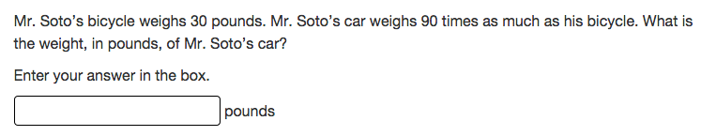

**Globe Santa**

We are still accepting donations for the BPS Globe Santa Drive! All donations must be submitted by Friday, 12/16.

**Conley PAWS**

Students receive Conley Paws for “Paw-sitive” behavior. The following students received a PAW last week: Isis Turner, Jeffery Germaine, Kalvin Cromwell, Ryan Robles, Ashanti Powell, James Christopher, and Immanuel Brooks.

**Student of the Month: November**

Below are the names of our Students of the Month for November! These students will attend a special pizza party on Friday! Congratulations to all of our Students of the Month!

|  |  |
| --- | --- |
| Ms. Brownell | Camila Garcia & Ryan Robles |
| Ms. Perry | Yerniel Gonzalez & Dymara Sylvester |
| Ms. McPhillips | Josue Nunez Veras |
| Ms. Liebmann | Natalie Guzman |
| Ms. Soloff | Liliana Disla |
| Ms. Gillespie | August Jack |
| Mr. Harris | Shenell Thomas |
| Ms. Blair | Giselle Noordzij |
| Ms. Marrero | Katherine Boves Aguilar |
| Ms. Irvin | Bethany Montas |
| Ms. Sheehan | Marcum Lovett & Isabella Torres |
| Ms. Achour | Kenaj Murphy Jones |
| Ms. Nery | Autumn Burmester & Yanelis Zamora |