**Welcome Back and February Vacation!!**

We hope everyone enjoyed our unexpected long weekend! As a reminder, our February Vacation is from Monday, 2/20 – Friday, 2/24. All students are expected to report back to school on Monday, 2/27.

**Latino Families United at the Conley School**

Dear families,

It is finally time for our next meeting to ***be held on Thursday,*** February 16, 2017 from 6:00-8:00. This time it will be a movie night for the kids! Mr. Foley will be available towards the beginning of the evening to discuss recent events in the political world that may impact our children and families. This will be a platform to bring any and all questions or concerns. Please come so that you can meet other Conley Latino families. There will be pizza and we will be showing the movie Trolls!

If you have any questions please contact me. Hope to see you there!

Priscilla Valentine

617 828-9025

phiguera@bostonpublicschools.org

**Our Instructional Focus**

***As educators we will collaboratively plan and scaffold lessons to ensure access to Cognitively Demanding Tasks (CDTs) for ALL students as demonstrated through their speaking and listening skills and student work.***

**Latino Families United at the Conley School**

Ya es hora para nuestra próxima reunión que se llevara a cabo el ***Jueves, 16 de Febrero de 2017 de 6:00-8:00***. Esta vez será una noche de película para los niños. El señor Foley estará disponible hacia el comienzo de la noche para discutir los acontecimientos recientes en el mundo político que pueden afectar a nuestros niños y por supuesto a nuestras familias. Será una plataforma para traer todas y cada una de preguntas o inquietudes. Por favor vengan para que puedan conocer a otras familias Latinas de la escuela Conley y para que su familia pueda disfrutar. Habrá pizza y estaremos mostrando la película Trolls!

Si tiene alguna pregunta por favor comuníquense conmigo.  Espero verlos a todos!

**Summer in February Fundraiser!**

On Friday, 2/17 we are having our Annual Summer in February Fundraiser!! With a $1 donation, students can wear the “summer clothes” to school. Students are allowed to wear t-shirts, hat, sunglasses, and shorts over their pants! Wear your summer gear and help raise money for the Conley!!

**AWC Invitees Informational Session**

**Thursday, 3/2**

We are hosting an informational session on Thursday, 3/2 from 1:30 – 2:00 for those families whose child has qualified for Advance Work Class (AWC) for the 2017 – 2018 SY. This session will outline what our 4th and 5th grade programs look like at the Conley. Participates will also have an opportunity to meet our 4th and 5th grade team. More information to follow.

**Updates form School Parent Council!**

**Nature Vision Catalog Sale:**

Nature's Vision catalogs will be going out this week for our winter fundraiser. This "green" fundraiser catalog is full of environmentally themed products and was a big hit last year. Show friends and family over winter break! More information to follow about online options. The fundraiser will go through Wednesday, March 8th.

**School Parent Council Meeting!**

Our next meeting is scheduled for Thursday, 3/2 from 6:30 – 7:30 pm. As always, pizza and babysitting will be provided. Please join us!

**Spring Fling!!**

MARK YOUR CALENDARS!!

Friday, May 19th at Napper Tandy’s in Roslindale!

**PARCC Question of the Week**

Each week we will provide a PARCC question. All students in grades 3 – 5 are required to answer our PARCC question of the week! Students, please turn in your answers to your teacher!

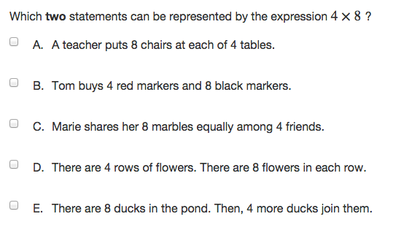

**Spelling Bee**

We are hosting the final round of our Spelling Bee on Friday, 2/17 from 1:00 – 2:00. The winner of this “Bee” will participate in the City Wide Spelling Bee! Families are welcome to join us on Friday! Best of luck to all of our participants!