**Our Instructional Focus**

***As educators we will collaboratively plan and scaffold lessons to ensure access to Cognitively Demanding Tasks (CDTs) for ALL students as demonstrated through their speaking and listening skills and student work.***

**Community Events:**

**Making Music Matters!**

**Spring Concert!**

Making Music Matters proudly invites you to our 2016 – 2017 Spring Concert featuring the MMM Ensemble: Students from the Bates, Conley, Mozart, Ohrenberger, and Philbrick Schools. This event is on Thursday, March 23 @ 7pm and will take place at the Washington Irving Middle School, 105 Cummins Highway, Roslindale

**Civic Saturdays**

**Sponsored by RISE (Roslindale is for Everyone)**

Boston Public Schools Educator Andrew Vega will lead a discussion entitled:   
*“More then a Safety Pin: From Ally to Disruptor”*. Saturday, 3/25 from 2:30 – 4:30 pm at the Roslindale Community Center, 6 Cummins Highway Roslindale MA.

**City Wide Spelling Bee!**

On Saturday, March 18th our Conley Spelling Bee Champion, Dylan Huynh, represented the Conley at the City Wide Spelling Bee. Dylan did an amazing job! He made it the second round of a very challenging spelling bee! Congratulations Dylan! You made the Conley proud!! Keep up the good work! A special thank you to Ms. Achour for organizing yet another Conley Spelling Bee! Thank you Ms. Achour!

**Conley Multiplication Bee**

On Friday, 3/17 Ms. Sheehan hosted a “practice” Multiplication Bee! All of our 3rd, 4th, and 5th grade students were invited to attend. After a highly competitive round, the bee came down to two students, our super star 5th grade student Ahmed Salah and our super star 4th grade student Michaleen Lovett. Although both students clearly knew their facts, Ahmed Salah ended up winning the bee! Congratulations to all of our students but especially our winner, Ahmed Salah! We will be hosting another multiplication bee in the Spring!

**Conley PAWS**

Students receive Conley Paws for “Paw-sitive” behavior. The following students received a PAW last week: Mr. Gus & Ms. Donna (Rm. 104), Ms. Paul & Ms. Ebanks (Rm. 202), Auser Nau Mackenzie, Nathaniel Hendrickson, Majadi Ortiz, Dylan Huynh, Ahmed Salah, Michael Clark and Michaleen Lovett.

**Lost and Found**

We have LOTS of items in our Lost and Found! If your child has misplaced any items: gloves, hat, lunch box, etc. please feel free to come to the Conley and go through our “Lost and Found”. The “Lost and Found” is located outside of the cafeteria. We ask that all visitors please sign in at the office.

**Arrival Reminder!**

Please do not drop your child off at school before 8:15AM. We cannot monitor students who are dropped off before 8:15. Students should be dropped off no earlier than 8:16AM.

**Yearbooks**

Yearbook order forms will be going out at in the next two weeks. The cost is $10 per book. If your child started at the Conley after picture day we will do our best to take a photo to add to the yearbook.

**PARCC Question of the Week**

Each week we will provide a PARCC question. All students in grades 3 – 5 are required to answer our PARCC question of the week! Students, please turn in your answers to your teacher!

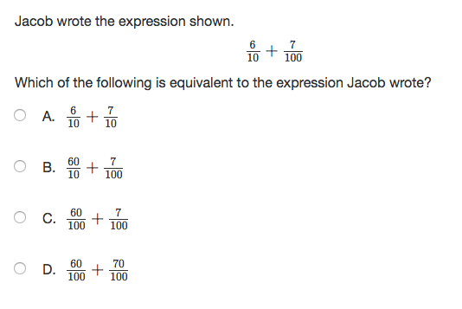

**MCAS 2.0 Testing Schedule**

ELA (3rd – 5th): April 10th, 11th, & 12th Make Up: 13th

SCI/Tech (5th): May 2nd and 3rd

Math (3-5): May 9th and May 16th

Make Up: Week of 22nd