**Room 203**

Hello Families!

Before April vacation the third graders in room 203 were busy promoting our outdoor classroom fundraiser and we are now looking forward to putting some of our new garden tools to work. We are feeling fortunate to have some volunteers from Pearson visit our school Friday to take care of some of the preliminary work and heavy lifting and clipping.

The students had their first go at MCAS before break and put forth some excellent effort. Big thanks to SPC for the words of encouragement and treats that they offered to the children. We will be sharpening the skills and strategies we have learned this year in preparation for the Math portion of state testing on May 9th and 16th.

**Room 203…continued**

In other news the students in room 203 are applying reading, writing, research, technology, and team-work skills to create Google Slides projects. The class has been working in small groups to sort/group information and develop topics based on nonfiction research. After detailed discussions and note taking the study groups are working cooperatively to build a teaching presentation that conveys their ideas and information clearly. Keep up the great work everybody!

**Spring Fling!!**

**Friday, May 19th**

**@ Napper Tandy’s in Roslindale Square**

Our Spring Fling Fundraiser is just **4 weeks** away! This is event is a CRITICAL fundraiser for our school! All proceeds from this event funds our partnership with the Eliot School of Fine Arts. The Eliot School provides all students in grades K2 – 5th Visual Arts and/or Woodworking classes! We need your support! Much more information to follow!

**Our Instructional Focus**

***As educators we will collaboratively plan and scaffold lessons to ensure access to Cognitively Demanding Tasks (CDTs) for ALL students as demonstrated through their speaking and listening skills and student work.***

**MCAS 2.0 Question of the Week**

Each week we will provide a MCAS 2.0 question. All students in grades 3 – 5 are required to answer our MCAS question of the week! Students, please turn in your answers to your teacher!

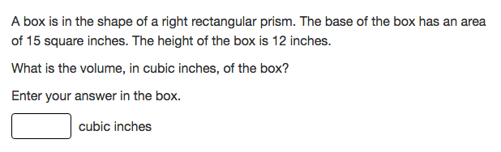

**MCAS Testing Schedule**

SCI/Tech (5th): May 2nd and 3rd,

Math (3-5): May 9th and May 16th,

Make Up: Week of 22nd

**Conley PAWS**

Students receive Conley Paws for “Paw-sitive” behavior. The following students received a PAW last week: Breanna Ezekwelu, Majadi Ortiz, Marven Courtois, Chris Cordero, Rolando Mestre, Kaylon Martinez, and Ayden Cruz

**School Parent Council Updates!!**

1. Help us raise money for Woodworking, Fine Arts and Hip Hop by selling Raffle Tickets for the Amazon Echo!  Tickets are on sale for $5 each or 5 for $20.  All families received 10 tickets to sell! Instead of keeping a portion of the raffle ticket, please return each ticket with a contact name and phone number along with the money.

2. Help us create a lottery ticket wall to be auctioned off at this year's Spring Fling.  Please send in a scratch ticket or cash for us to purchase tickets by Friday, May 5th.

3.  Start saving your gently used donations for the Conley Savers Donation Drive May 11th-13th!  All proceeds go to fund the Conley outdoor garden!