**BO3**

K0/K1 Students in Room B03 are learning and growing every day! They really love building, fixing and creating in our new "Fix It" Shop in our dramatic play area.  Students are exploring how things work, putting together flashlights, push lights, and matching locks and keys.  They are building vocabulary and conversational skills.    Students are doing a great job using persistent effort, asking questions, working together and seeking help when needed.  I'm so very proud of their efforts!

Our Literacy Unit of Color study has been so much fun!  Students are mixing colors to create new colors and we are now using the colors red, blue, yellow and white to make a beautiful array of skin colors to create our self-portraits.  
     Our next unit of study is Shadows and Reflections.  We have a lot of exciting, engaging projects to look forward to!

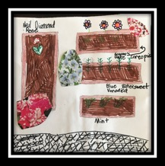

**$1.00-WEAR GREEN THIS FRIDAY**

Wear green to support our outdoor classroom!

Your contribution of $1.00 will fund the gardening tools and supplies for our community.

Let’s reinvigorate our outdoor classroom!

Artist: Giselle Noordzij

**Our Instructional Focus**

***As educators we will collaboratively plan and scaffold lessons to ensure access to Cognitively Demanding Tasks (CDTs) for ALL students as demonstrated through their speaking and listening skills and student work.***

**MCAS 2.0 Question of the Week**

Each week we will provide a MCAS 2.0 question. All students in grades 3 – 5 are required to answer our MCAS question of the week! Students, please turn in your answers to your teacher!

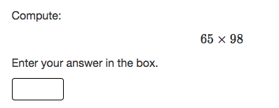

**MCAS 2.0 Testing Schedule**

ELA (3rd – 5th): April 10th, 11th, & 12th Make Up: 13th

SCI/Tech (5th): May 2nd and 3rd

Math (3-5): May 9th and May 16th

Make Up: Week of 22nd

**Penny Drive for Our Outdoor Classroom**

Starting this week, we are having a “Penny Drive” for our Outdoor Classroom. Every classroom has a classroom penny bank! We are asking that our students bring in change for their classroom piggy bank! This drive will take place through the end of May! Thank you in advance for participating!

**Conley PAWS**

Students receive Conley Paws for “Paw-sitive” behavior. The following students received a PAW last week: Miracle Solomon Ash, Kingston James, Jesdian Vargas, Brooklynn Veale, August Jack, Devin Clark , Gerald Reed, Thomas Valadao, and Majadi Ortiz

**SPC Meeting!**

Please join us on Thursday, 4/6 @ 6:30 pm for our monthly School Parent Council Meeting! **We have seen a significant decline in the number of families that attend our SPC Meetings! Please join us! We need your support!! As a reminder pizza and babysitting will be provided.**

**MCAS Family Night!**

**Thursday, 4/6 from 6:00 – 6:30**

Please join us to learn more about the new MCAS 2.0 standardized test! Participating families will get a chance to look at test items, learn how they can support their child, and how we are preparing our students! More information to follow.