**Multicultural Night**

**June 1st, 5-7 pm**

The Conley School is abuzz with preparations for Multicultural Night!  We are rehearsing our songs and dances, putting the finishing touches on projects, and preparing some special decorations for the night. It feels like Room 206 is overflowing with beautiful student creations! I'm so proud of the work students have done over the last few months, and we can't wait to share with you what we've learned!

**All students will be performing in our concert and sharing their original artwork and research.** Please bring a dish to share!  This year we are also asking families to bring lawn chairs and picnic blankets for seating.  We can't wait to see you there! June 1st, 5-7 pm on the green-top at the Conley!

**Spring Fling Fundraiser!!**

Huge “thank-you” to everyone who joined us last Friday night for our Spring Fling fundraiser! We raised nearly $9,000 (a record for us!!)!! Thank you to everyone that supported this event! Whether you attended, bought raffle tickets, donated items, and/or planned the event we are blessed for our communities’ involvement and support! A special thank you to SPC and specifically our co-chairs Cherry Suarez and Martha Butler! Thanks again!!

**Savers Fundraiser Update!!**

Last week we held a fundraiser at Savers in West Roxbury and it was a huge success! Thanks to everyone’s donations we raised $447 that will go towards our outdoor classroom! Thank you to everyone who donated to Savers last week!

**Conley Golf Fundraiser!**

We are hosting another Conley Golf Classic! Join us on Saturday, June 17th at North Hill Country Club in Duxbury, MA @ 11:45. We are charging $80 per golfer that includes 18 holes of golf, cart, and BBQ. Get a foursome together, or bring a friend, or come by yourself! All abilities are welcome! If you are interested please email Mr. Foley at [jfoley3@bostonpublicschools.org](mailto:jfoley3@bostonpublicschools.org)

Due 6/28/2017

Parent Climate Surveys are now available in 10 languages online. Please send families to [bostonpublicschools.org/climatesurvey](http://bostonpublicschools.org/climatesurvey" \t "_blank) today to complete their survey!

I collected 160.00

**Our Instructional Focus**

***As educators we will collaboratively plan and scaffold lessons to ensure access to Cognitively Demanding Tasks (CDTs) for ALL students as demonstrated through their speaking and listening skills and student work.***

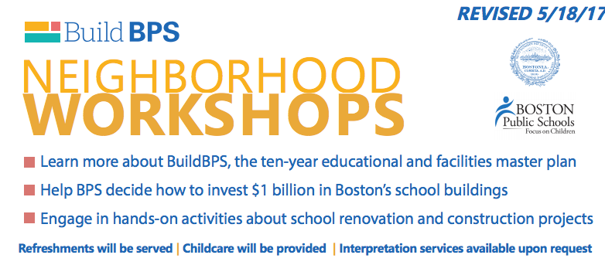

The Roslindale, West Roxbury,

& Hyde Park Workshop is on Thursday, June 1st

from 5:30 – 8:00 at the Ohrenberger, 175

West Boundary Rd. Conley families should

Attend this meeting after our Multi-

Cultural Potluck.

**MCAS Testing**!

We are nearly done with MCAS Testing!

We will be administering “make ups” this week.

Congratulations to all of students for

working so hard and completing their MCAS

testing!

**Mark Your Calendars!**

**Making Music Matters: Final Concert (4th and 5th)** Thursday, June 1st from 11:20 – 12:10

**Multi-Cultural Potluck:** Thursday, June 1st (5:00 - 7:00 pm)

**Field Day: Friday,** June 2nd

**Whole School Moving Up Day:** Monday, June 12 (10:30 – 11:00)

**Hip Hop Performance:** Friday, June 16th @ 1:00 (all students are performing!)

**Conley Golf Classic:** Sat, June 17th @ 11:45 @ North Hill Country Club**,** Duxbury, MA

**K2 Moving Up Day**: Tuesday 6/20 @ 9:30 am

**Whole School Field Trip: K0 – 2nd**: Wednesday, 6/21, Franklin Park Zoo & 3rd – 5th Castle Island

**5th Grade Moving Up Ceremony**: Thursday, 6/22 @ 10:00 am

**K0/K1: Moving Up Ceremony**: Friday, 6/23 @ 1:00 pm

**EOY Award Ceremonies** (Grades: 1st, 2nd, 3rd, & 4th): Monday, 6/26 @ 1:00 pm

**Minimum Day**: Tuesday, 6/27, Students are dismissed at 12:30

**Last Day!!**: Wednesday, 6/28, Students are dismissed at 12:30