**THIS WEEK!!!**

**Multicultural Night**

**June 1st, 5-7 pm**

The Conley School is abuzz with preparations for Multicultural Night!  We are rehearsing our songs and dances, putting the finishing touches on projects, and preparing some special decorations for the night. It feels like Room 206 is overflowing with beautiful student creations! We are so proud of the work students have done over the last few months, and we can't wait to share with you what we've learned!

**All students will be performing in our concert and sharing their original artwork and research.** Please bring a dish to share!  This year we are also asking families to bring lawn chairs and picnic blankets for seating.  We can't wait to see you there! June 1st, 5-7 pm on the green-top at the Conley!  FYI: We are video tapping students’ performances for our own personal use! Videos will not be shared via social media.

**Grade 3 (207)**

Where is Mr. Sun? (5)

Old Winter is here to stay (7)

Warm weather, please come! (5)

Poetry is in our veins! We’ve been learning about different kinds of Poetry – Acrostic, Rhyming, Simile, Alliteration, Haiku). Learning about the country, Japan was a huge part of our EL Module where we learned about the great Japanese poet Basho as we traveled along with Jack and Annie in their adventures in Mary Pope Osborne’s “Dragon of the Red Dawn.” To honor all “Mothers” on Mother’s Day, we devoted the week creating different kinds of poems for them. Please come and visit our Bulletin Board on the second-floor hallway and enjoy our Haikus.

Strategy-strategy-strategy…we’ve been hearing about this word forever! Yes indeed, it’s all about ***strategy***, focus,and hard work. At some point towards the end of the school year, our knowledge in ELA and Math is put to the test. We joined in the excitement of taking our very first ever MCAS as we applied everything we learned in 3rd Grade. And those “peppermints” did the trick 😉. We thank you all for cheering us on.

**Our Instructional Focus**

***As educators we will collaboratively plan and scaffold lessons to ensure access to Cognitively Demanding Tasks (CDTs) for ALL students as demonstrated through their speaking and listening skills and student work.***

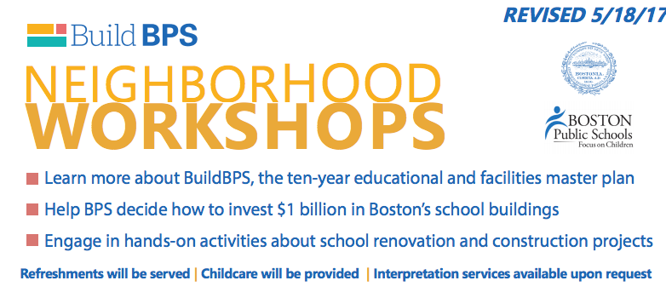

The Roslindale, West Roxbury,

& Hyde Park Workshop is on Thursday, June 1st

from 5:30 – 8:00 at the Ohrenberger, 175

West Boundary Rd. Conley families should

Attend this meeting after our Multi-

Cultural Potluck.

**Conley Golf Fundraiser!**

We are hosting another Conley Golf Classic! Join us on Saturday, June 17th at North Hill Country Club in Duxbury, MA @ 11:45. We are charging $80 per golfer that includes 18 holes of golf, cart, and BBQ. Get a foursome together, or bring a friend, or come by yourself! All abilities are welcome! If you are interested please email Mr. Foley at [jfoley3@bostonpublicschools.org](mailto:jfoley3@bostonpublicschools.org)

**Mark Your Calendars!**

**Making Music Matters: Final Concert (4th and 5th)** Thursday, June 1st from 11:20 – 12:10

**Multi-Cultural Potluck:** Thursday, June 1st (5:00 - 7:00 pm)

**Field Day: Friday,** June 2nd

**Whole School Moving Up Day:** Monday, June 12 (10:30 – 11:00)

**Hip Hop Performance:** Friday, June 16th @ 1:00 (all students are performing!)

**Conley Golf Classic:** Sat, June 17th @ 11:45 @ North Hill Country Club**,** Duxbury, MA

**K2 Moving Up Day**: Tuesday 6/20 @ 9:30 am

**Whole School Field Trip: K0 – 2nd**: Wednesday, 6/21, Franklin Park Zoo & 3rd – 5th Castle Island

**5th Grade Moving Up Ceremony**: Thursday, 6/22 @ 10:00 am

**K0/K1: Moving Up Ceremony**: Friday, 6/23 @ 1:00 pm

**EOY Award Ceremonies** (Grades: 1st, 2nd, 3rd, & 4th): Monday, 6/26 @ 1:00 pm

**Minimum Day**: Tuesday, 6/27, Students are dismissed at 12:30

**Last Day!!**: Wednesday, 6/28, Students are dismissed at 12:30