George H. Conley School
Early Childhood
Handbook
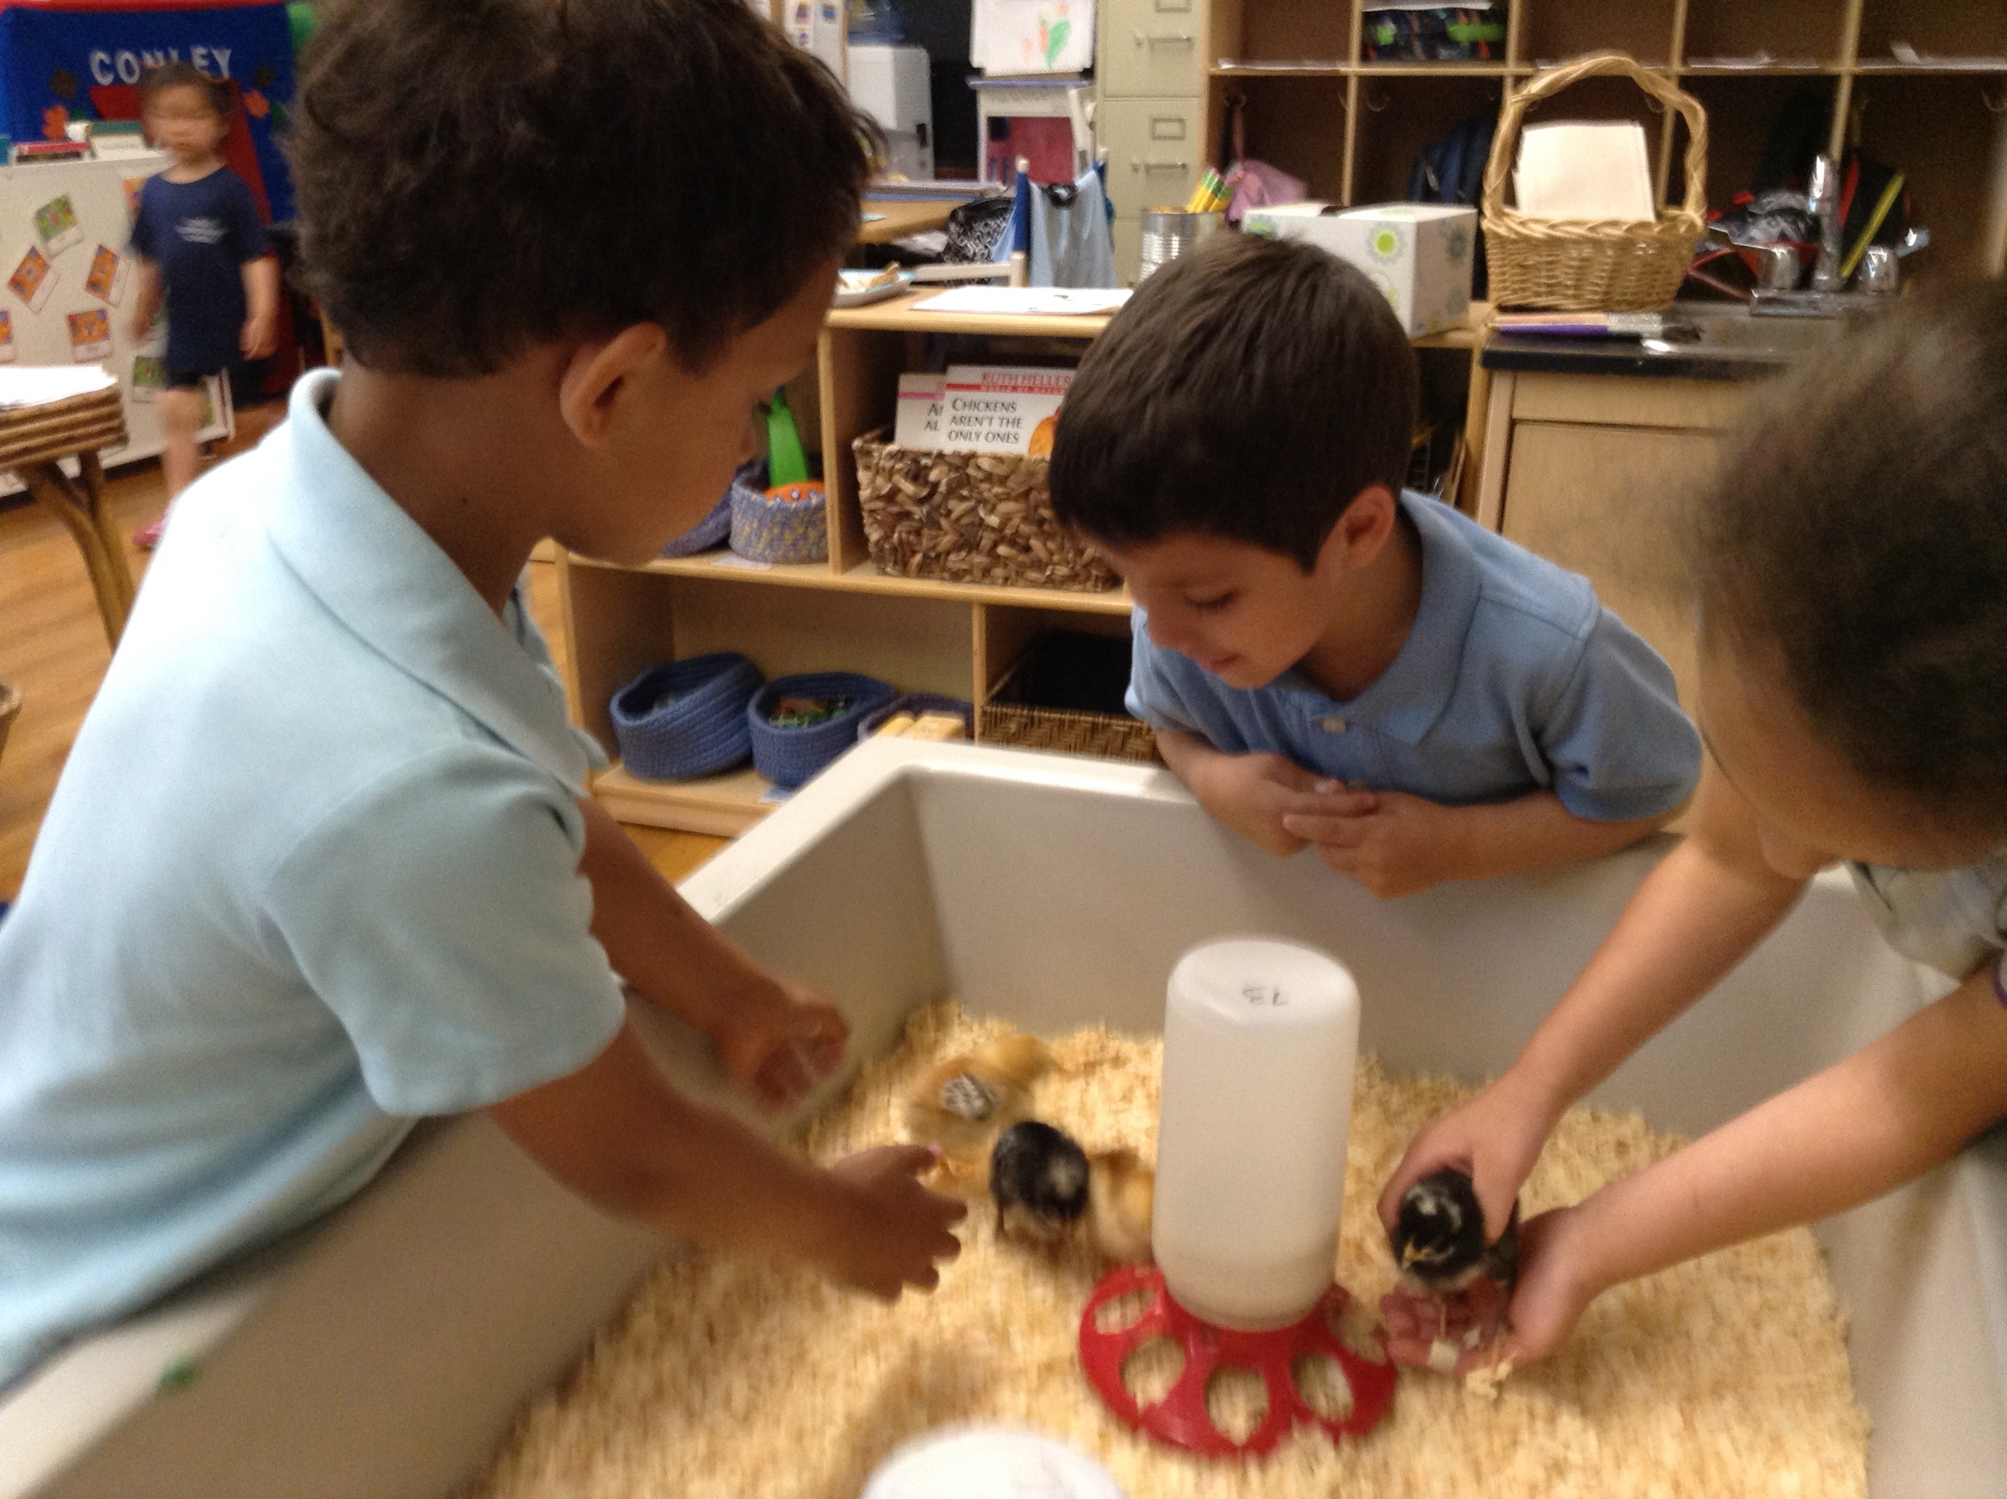



Table of Contents
Classroom Teachers/Specialists/Therapists
Arrival & Dismissal
Breakfast & Lunch
Uniforms & Clothing
Health & Illness
Media Disclaimer
Birthdays
Home/School Folders
Bring to School List
Parent Volunteers
Fundraisers
Fieldtrips
Curriculum Calendar
Calendar of Special Events
Early Childhood Curriculum Objectives

George H. Conley School
Staff List 2014 -2015
Principal
Joseph D. Foley
Administrative Assistant
Danika A. Ford
Teachers |  | Room |  |  |  | Specialists
Kim McPhillips | Early Childhood | B03 |  |  |  | Leesha Boylan |  | Art
Antonietta Brownell | KO/K1 | 107 |  |  |  | ? |  | Enrichment/Math
Pricilla Valentine | K2 | 105 |  |  |  | Suzette Connery |  | ABA
Meridith Markunas | K2 | 105  105 |  |  |  | Brendon Hogan |  | Music
? |  |  |  |  |  | Dominique Wilkins |  | P.E.
 |  |  |  |  |  | Sarah Collela |  | Science
 |  |  |  |  |  | Speech/Language Pathologists
 |  |  |  |  |  | Carla Russin Ryder
 |  |  |  |  |  | Occupational Therapist
 |  |  |  |  |  | Mike Wilkins
Custodian
?
Paraprofessionals
Margery Grady | Early Childhood | B03 |  |  |  | Nurse
Paula Harris Faison | K2 | 103 |  |  |  | Sandy Hurwitch
Gloria Todesco | KO/k1 intergrated | 104
?Inclusion Specialist
?K2 inclusion Para
 |  |  |  |  |  | School Psychologist
 |  |  |  |  |  | Jennifer Medeiros-Crabbe
 |  |  |  |  |  | Vision Resource
 |  | 207 |  |  |  | Merryl Kaye
ETF | Mary Jane Brady |  |  |  |  | Physical Therapist
 |  |  |  |  |  | Marcy Wanzer



Bus Riders
Students living outside the walk zone have been assigned to a bus. The transportation department will mail you a notice that will indicate a route number. This is not your child’s bus number. The notice will indicate a pick up and drop off time. The schedule might be slightly inconsistent at the beginning of the year, so it is recommended that you arrive 15 minutes prior to pick up and drop off. If your child takes a bus home, an adult must be there to greet him/her. The bus driver cannot release your child if someone is not at the bus stop waiting.

Children who ride the bus will be given a bus tag on the first day of school. They are expected to wear it each morning and will come home with it in the afternoon. If your child is a bus rider and will not be riding a bus on a certain day, please put a note in your child’s folder stating who will be picking your child up from school.

Arrival
Classroom doors will open at 8:20 am. Please do not come earlier because teachers will be busy getting the classroom ready for the day. We ask that all children arrive by 8:30 am so that they have ample time to enjoy the morning activities. Chronic tardiness takes away from your child’s experience and often sets them up for frustration when they arrive just before or at the beginning of clean up time. Please meet the class outside on nice days and inside the classroom on days that it rains.

Saying Goodbye
It is sometimes hard for children to separate from their families in the morning. It can also be difficult for families to separate from their children, especially on the first day. Teachers will meet children and families in the schoolyard in front of the school each morning. Goodbyes will be said in the schoolyard and parents will be asked not to come into the school building. When parents come into the classroom, some children can be reluctant to join in activities. It can also prolong the sadness of saying goodbye. If you want to know how your child is doing, you can call the school and we can give you an update. Usually it only takes a few minutes for children to settle in, although during drop off time it may seem that they will be sad all day.

Dismissal
The school day ends at 2:25 pm. Children will be picked up from outside in the warmer weather but can be picked up inside during times of rain and snow. Poplar Street must be clear for buses, so please do not park on Poplar street when you come to pick up your child. Please call the office to notify us if you are going to be late. While we understand that certain unavoidable events happen, it is important that children are picked up on time. Teachers often have afternoon meetings, classes and workshops and must be able to leave school at the scheduled time.

All adults who will be picking up your child must be listed on the emergency contact form. If your child usually takes the bus, and you or someone in the family is going to pick up your child instead, you must either send in a written note in your child’s folder indicating the change or you must call the office no later than 1:30PM so that classroom teachers have time to receive the message and make the appropriate arrangements. If someone not authorized on the emergency card is going to pick up your child, we must receive either a note and/or phone call stating who will pick up instead. When a new person arrives to pick up your child, we will ask for identification. This is to ensure the safety of all our students.

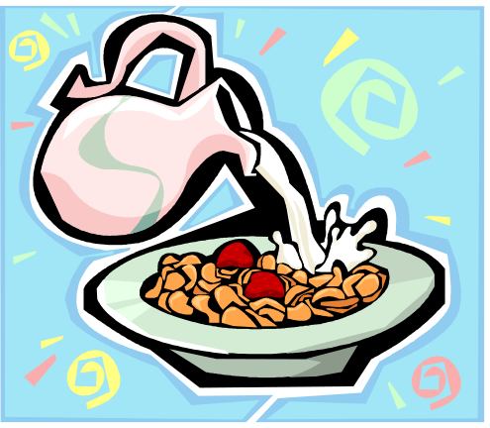

Breakfast
Breakfast is offered to children each morning free of charge in the classroom from 8:20-8:45. Please plan for your child to have breakfast if you plan to be late.



Lunch/Snack
Lunch is available free of charge while we send out and collect lunch forms. Your child may eat school lunch or bring a lunch from home. Please make sure your child’s lunch box/bag is labeled with his/her first and last name. Please refrain from sending candy or soda in your child’s lunch. Many parents ask about snack. Since lunch and breakfast are served, snack is optional. If your child needs a snack, please let your teacher know and we will make arrangements. If you are sending in a lunch please make sure that your child’s lunchbox contains an ice pack, since we do not have refrigerators in the classroom.



Clothing

Uniforms: There is a mandatory school uniform policy. The uniform is blue pants/skirt and a light blue collared shirt. Children are active in school and their clothes get a real workout. Some paint is hard to get out, so please don’t send children in clothes that you don’t want to get dirty or possibly stained. Also, please label all of your children’s clothes (on tag with permanent marker). Even small items like socks, underwear, mittens and hats should be labeled.
Extra clothes: Your child should have at least one complete set of clothes in the cubby at all times (pants, shirt, sweater/sweatshirt, socks, shoes and a pair of underwear). Please check regularly to make sure your child’s cubby is well stocked with extra clothes. We will also send home a checklist letting you know when we have run out of a particular item. With all of the painting, water play, outdoor time and eating children do, changing clothes is a frequent event. Extra clothes do not have to be the school uniform. Considering your child’s age, you may want to send in two sets of clothing. Each child will be assigned a cubby. Extra clothes and outdoor gear will be kept in the classroom stall in the bathroom downstairs.
Outerwear: Children will spend time outdoors almost every day. On rainy days, they need raincoats and rain boots. Children should have an extra pair of firm slippers to keep at school in case of rain or snow. In winter, we recommend a snowsuit (or snow pants and a warm coat), waterproof mittens, a hat, and snow boots. If it is snowy, muddy and/or wet, sneakers will not protect your child’s feet from the cold. Please make sure your child has footwear appropriate for all kinds of weather. Please label your child’s belongings.



Health and Illness
Our health policy has been designed with both parents and children in mind. If we believe (school nurse, teachers, principal) that your child needs to see a doctor, if they are contagious, or if they require prolonged individual staff attention that interferes with the safe functioning of the group, we will request that children be picked up from school. If we ask you to pick up your child, we expect that this happen promptly so that your child can be taken to more comfortable surroundings. If you will be away from your typical phone number, please let us know the best way to reach you. Also, in the event that we cannot reach you and we must call an emergency contact, please list someone we can easily contact during the day and for whom transportation will not be an issue.
Please follow the guidelines regarding a child’s return to school after being sent home sick. Some illnesses are highly contagious, such as: diarrhea, vomiting, strep throat and conjunctivitis. A child returning to school while contagious often results in other students and teachers getting sick over and over again. This affects EVERY child in the room, not just one sick child.
Fever: Children should not be at school if they have a fever over 100 degrees by mouth (which is the same as 101 degrees rectally or 99 degrees in the armpit). If children are sent home with a fever of 101 degrees or higher, they must remain at home fever free for 24 hours before returning to school (without Tylenol or Motrin keeping the fever down).
Diarrhea: Children with diarrhea will be sent home if the diarrhea is unable to be contained or controlled by toilet use.

Colds: Colds are common in the schools, and no reason to keep the child at home if the child is well enough to participate as usual. Any child who comes to school with a cold is expected to take part in all normal outdoor activities. If a child shows unusual tiredness, irritability, persistent crying, difficulty breathing, and is requiring so much care that it interferes with the teacher’s ability to care for the rest of the children, we will ask you to pick up your child.
Vomiting: A child will be sent home from school when he/she vomits. Teachers will use their good judgment before sending a child home in order to decide whether the child might have just “spit up” or choked from crying hard or coughing. If the teacher/nurse decides the vomiting is what we term “projectile,” the child will be sent home and asked to remain home for 24 hours vomit free.
Conjunctivitis: This is a highly contagious infection of the eye, often marked by itching and a yellow/green discharge. If it is suspected, we will ask you to pick up your child and have him/her checked by a doctor. If the doctor diagnoses it as a bacterial infection, your child must be treated for 24 hours and the discharge must be gone before your child returns to school.
Strep Throat: This can show a variety of symptoms. You should have your doctor check for strep if your child has a continuing fever, a rash or a sore throat. Children who have strep are generally treated with a 10-day dose of antibiotics. Children with positive strep culture should stay home until they have had at least 24 hours of medicine and their fever has been normal for 24 hours.
Allergies: Please keep us up to date about any allergies your child may have to foods, animal fur, pollens, sunscreens, etc.


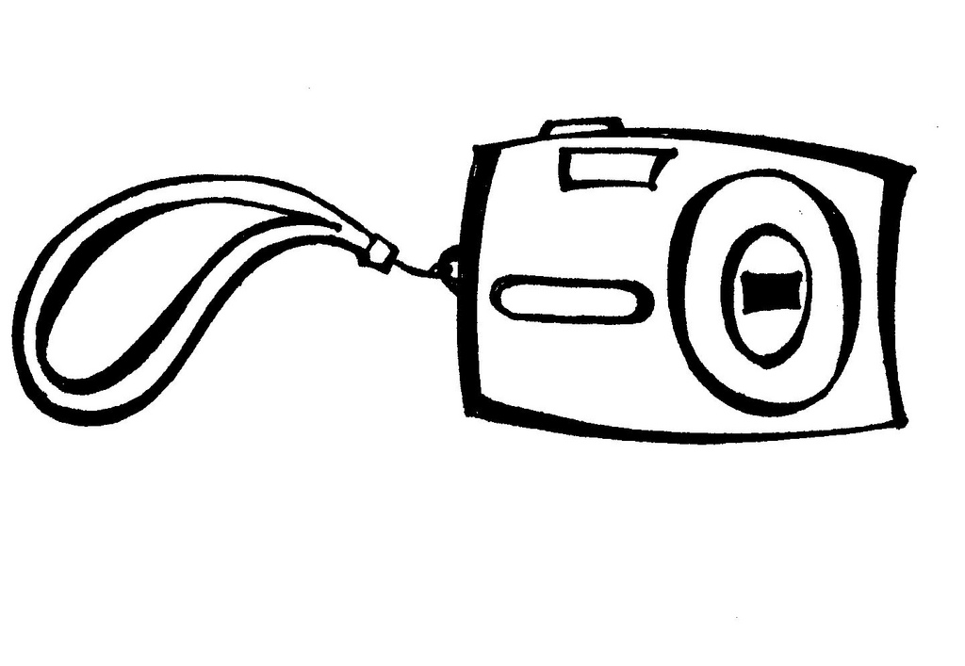
Media Disclaimer

Photography and video are used in the classroom in many ways and serve many purposes. Photos are used to label children’s individual spaces and learning groups and both photos and videos document learning experiences to share with children, families, and other members of the school community. Photos can be seen in class-made books, on bulletin boards and in the classroom newsletter. Later in the year, children will become the classroom photographers! You will receive a media release form in the Boston Public Schools handbook.

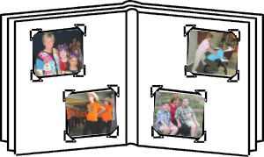



Birthdays

Birthdays are a special time for young children. We will take the opportunity to honor each child on (or near) his/her birthday. If your child’s birthday was over the summer, we will choose a day toward the end of the year to celebrate. If parents want to have a celebration in school with treats, this needs to be arranged with the classroom teacher. Treats do need to be a healthy choice. Please go over this with your classroom teacher. Birthday celebrations are done right after lunch as the dessert.



Home/School
Folders

Each child will receive home/school folder. This is an important means of communication between home and school. In the left side of the folder, we will send home school notices, classroom newsletters, and any of your child’s work that can stay at home. In the right side of the folder, we will place notices that must be signed and returned and any work that you and your child will do together at home that will be returning to school. It is important to empty the folder daily in order to discuss with your child what he or she is doing in school and to receive information in a timely manner. Please use this folder to send notes and information to school. Folders should be sent to school each day and will be checked upon arrival each morning.

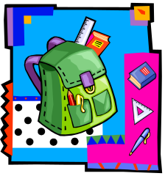

Please bring to school:

- A backpack big enough to hold a standard size folder

- At least one change of clothes including a shirt, pants, underwear, socks and shoes (labeled with your child’s name)

- Diapers or pull-ups (if needed)

- Completed emergency form and family questionnaire, and any changes that occur throughout the year.

- Clorox Wipes and a box of tissues.

- The list of school supplies requested in the parent letter by each teacher.



Please leave at home:

- All toys (We have found that when children bring toys from home they can become more focused on the toy than on the classroom materials.) In order to assist us in creating an equitable, peaceful environment, please help your child keep his/her toys at home. We can offer a show and tell, but this needs to be arranged with the classroom teacher. If a child needs a specific toy it needs to be arranged with the classroom teacher.
Parent Volunteers

The Conley School always welcomes parent volunteers. If you are interested in classroom volunteering, please see your teacher for details. A parent can volunteer in the classroom, offer a classroom donation, chaperone fieldtrips, or help with curriculum prep. Before a parent can volunteer in the classroom they will need to fill out a CORI form. Once approved times can be set up with your corresponding teacher.

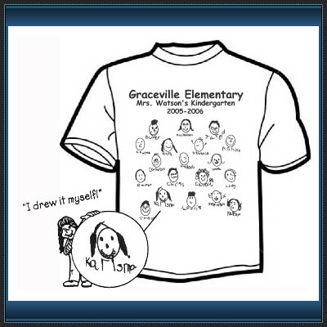
Fundraisers
We usually have one fundraiser for the early childhood classes. This is not a whole school fundraiser. We sell t-shirts, tote bags and sweatshirts. We encourage all parents to buy a classroom t-shirt. The cost of the t-shirt is 15.00. This t-shirt is the children’s drawing of themselves. It’s a great keepsake and its perfect for when we go on our fieldtrips. It helps keep all the children together.

Field Trips

Fieldtrips are a big part of the Early Childhood program. We believe in supplementing classroom curriculum with exposure to the real world is vital for children. Please see our calendar of events for fieldtrips. Before each fieldtrip you will be asked to fill out a permission slip and provide what is asked. If a child does not have a permission slip, they he/she will not be able to attend the fieldtrip.


Parent Conferences/Report Cards

You will be able to meet with your teacher twice a year for a conference regarding your child’s progress report. Each student will receive a progress report 2 times a year. An IEP student will have other times as well that they can meet with their teacher, I.e. annual reviews, and revaluations. An IEP student receives 3 progress reports a year that is mandated by the Massachusetts department of education.

OWL/BB Curriculum Calendar
September Unit
Cycle/Unit One-BB weeks 1-5
Cycle/Unit Two- weeks 6-10
Cycle/Unit Three-BB weeks 11-15
Cycle/Unit Four–BB weeks 16-20
Cycle/Unit Five–BB weeks 21- 25
Cycle/Unit 6- BB weeks 26-30
Prep Students for Next Year/Clean
Portfolio Showcase /report card conference
Holidays/School Vacations/ No School

September
S | M | T | W | T | F | S
 |  | 1 | 2 | 3 | 4 | 5
6 | 7 | 8 | 9 | 10 | 11 | 12
13 | 14 | 15 | 16 | 17 | 18 | 19
20 | 21 | 22 | 23 | 24 | 25 | 26
27 | 28 | 29 | 30

October
S | M | T | W | T | F | S
 |  |  |  | 1 | 2 | 3
4 | 5 | 6 | 7 | 8 | 9 | 10
11 | 12 | 13 | 14 | 15 | 16 | 17
18 | 19 | 20 | 21 | 22 | 23 | 24
25 | 26 | 27 | 28 | 29 | 30 | 31
November
S | M | T | W | T | F | S
1 | 2 | 3 | 4 | 5 | 6 | 7
8 | 9 | 10 | 11 | 12 | 13 | 14
15 | 16 | 17 | 18 | 19 | 20 | 21
22 | 23 | 24 | 25 | 26 | 27 | 28
29 | 30
December
S | M | T | W | T | F | S
 |  | 1 | 2 | 3 | 4 | 5
6 | 7 | 8 | 9 | 10 | 11 | 12
13 | 14 | 15 | 16 | 17 | 18 | 19
20 | 21 | 22 | 23 | 24 | 25 | 26
27 | 28 | 29 | 30 | 31
January
S | M | T | W | T | F | S
 |  |  |  |  | 1 | 2
3 | 4 | 5 | 6 | 7 | 8 | 9
10 | 11 | 12 | 13 | 14 | 15 | 16
17 | 18 | 19 | 20 | 21 | 22 | 23
24 | 25 | 26 | 27 | 28 | 29 | 30
31
February
S | M | T | W | T | F | S
 | 1 | 2 | 3 | 4 | 5 | 6
7 | 8 | 9 | 10 | 11 | 12 | 13
14 | 15 | 16 | 17 | 18 | 19 | 20
21 | 22 | 23 | 24 | 25 | 26 | 27
28 | 29
March
S | M | T | W | T | F | S
 |  | 1 | 2 | 3 | 4 | 5
6 | 7 | 8 | 9 | 10 | 11 | 12
13 | 14 | 15 | 16 | 17 | 18 | 19
20 | 21 | 22 | 23 | 24 | 25 | 26
27 | 28 | 29 | 30 | 31
April
S | M | T | W | T | F | S
 |  |  |  |  | 1 | 2
3 | 4 | 5 | 6 | 7 | 8 | 9
10 | 11 | 12 | 13 | 14 | 15 | 16
17 | 18 | 19 | 20 | 21 | 22 | 23
24 | 25 | 26 | 27 | 28 | 29 | 30
May
S | M | T | W | T | F | S
1 | 2 | 3 | 4 | 5 | 6 | 7
8 | 9 | 10 | 11 | 12 | 13 | 14
15 | 16 | 17 | 18 | 19 | 20 | 21
22 | 23 | 24 | 25 | 26 | 27 | 28
29 | 30 | 31
June
S | M | T | W | T | F | S
 |  |  | 1 | 2 | 3 | 4
5 | 6 | 7 | 8 | 9 | 10 | 11
12 | 13 | 14 | 15 | 16 | 17 | 18
19 | 20 | 21 | 22 | 23 | 24 | 25
26 | 27 | 28 | 29 | 30

Pumpkin Picking/Hayride- Oct TBA
Harvest Fest/Farm babies-Oct. 31
Community Fieldtrip-Nov. TBA
Holiday Party-December 22th
Swan Boats-June-TBA
Parent Workshop-Nov. TBA
Aquarium- TBA
Field Day/Talent Show- TBA

K1 ASSESSMENT SCHEDULE
Lap-D screener | 09/12-09/30 | None
PALS | 09/ 2015 and 01/2016 | 5/2016
EVT | 01/2016 | 5/2016
BB | 01/2016 | 5/2016
Report Card Conf | 01/2016 | 06/2016
Friendship celebration- Feb. 13
100th day of school –Feb.
Community Field Trip-Mar. TBA
Multicultural Night-April TBA
Spring Fling –April-TBA
Curious Creatures-May TBA
Franklin Park Zoo-June TBA
Parent Workshop-TBA

Boston Pubic Schools
K0/K1 Syllabus
Conley Elementary School

Instructional Objectives: Listed below is an overview of what students should know and be able to do as a result of their work this year. As the year progresses so do the skills your children will learn. Once something is taught it is reinforced throughout the year and built upon as the months go by. Once an objective is introduced it will be reinforced throughout the rest of the year. Please be sure to review these goals and complete weekly homework assignments with your child. The homework assignments will be developed to help reinforce and practice the skills and concepts your child is learning in school that week.

I. Language and Literacy
September/October – Children will:
- Use language in play situations and to tell needs, wants, or thoughts, tell a personal narrative
- Respond to own name and requests for action; asks and answers questions and gives directions
- Listen with attention and follow directions
- Recite songs, rhymes, and poems and engaged in word play
- Experiment with letter forms
- Indicate that their own writing conveys meaning
- Demonstrate increasing levels of sustained focus and engagement during read aloud times
- Choose to read or pretend to read books; understands that pictures, print and other symbols carry meaning; uses pictures to understand a book
- Recognize own name and the letters in their own name
- Name main characters and recall some main events in stories
- Participates in dramatic play that is influenced by stories read aloud
- Finds words with the same beginning sound
November/December- Children will:
- Engage in conversations and use language to enter into play situations
- Tell a personal narrative
- Use language to resolve conflicts
- Follow two step directions, and build up to multi-step directions
- Listen to and attend to several turns in a conversation
- Respond to verbal cues from a friend in dramatic play
- Identify different kinds of text (nonfiction, fiction)
- Recognize own name; name all letters in own name; write own name
- Name main characters and main events in a story
- Link characters emotions to their actions
- Find words with the same beginning sound; segments the beginning sound in words
- Substitute sounds to create new words

January/February- Children will:
- Engage in conversations and uses language and books to enter into play situations
- Read or pretends to read informational books (nonfiction)
- Relate events from familiar stories and books in sequence
- Use own experiences to understand story events and expository text; expresses the main idea of a story or other text in a way that shows increasing understanding
- Recognize several highly-familiar words in the environment or in books
- Listen to and attend to several turns in a conversation
- Segment the beginning sounds in words; discriminates between sounds that are the same and sounds that are different
- Separate words into syllables
- Follow multi-step directions
- Use new words and dialogue from stories
- Recognize names of other students
- Name many upper case letters
- Write own name using good approximations of some of the letters; composes and dictates or writes messages; writes for many purposes
March- Children will:
- Speak clearly using appropriate tone, inflection, and volume, so that the words can be understood
- Communicate using verbal and non-verbal cues
- Use sentences or phrases with at least five words
- Say words that complete rhymes, poems or story lines
- Listen to and attend to a variety of genres, seeks out nonfiction texts for information
- Demonstrate increasing levels of sustained focus and engagement during read alouds
- Show a steady increase in the number of words in their listening vocabulary
- Choose independently to read or pretend to read
- Understand that print and symbols carry meaning; understands that letters represent sounds and go together to make printed words; recognizes several highly familiar words
- Predict what will happen next in a story; recalls main events; uses and develops background knowledge to understand story events and make predictions
- Blend syllables together to form a word; substitutes one sound for another to create new words
- Experiment with letter forms by making letter-like and actual letters
April
- Listen to attends to poems, rhymes and songs on audiotapes
- Develop comprehension of the story’s main events; recalls main events; expresses main idea of the story
- Seeks out nonfiction texts to find information
- Tell a personal narrative; includes two or more events from the past while talking about or dictating personal narratives
- Use multiple word sentences and phrases
- Use own experiences to understand character’s feelings and motivations and story events
- Compose, dictate, or write messages
- Find words with the same beginning sounds and the same ending sounds
- Blend phonemes and onset-rimes to form words
- Substitute sounds to create new words
- Name many upper and lower case letters
May/June- Children will:
- Understand use of nonfiction text to find information
- Understand that pictures, print and other symbols carry meaning
- Write for many purposes; writes and draws using a variety of tools
- Use and shares books and other print in play situations
- Use own experiences to understand story events, characters and expository text
- Develop comprehension of the stories main events
- Discriminate between sounds that are the same and sounds that are different
- Produce words that end with the same sound
- Name all upper and many or all lower case letters
- Track print from left to right while pretending to read or reading books
- Show an increase in the number of words in listening and speaking vocabulary
Mathematics:
September/October- Children will:
- Count verbally
- Explore manipulatives
- Recognize and make groups of 2 or more
- Quickly recognize the number of objects in small groups (subitize)
- Name the number of objects in a group to 3
- Produce simple rhythmic patterns
- Connect number words to the quantities that they represent
- Make groups of five objects
- Count verbally to five with understanding
- Name familiar 2-dimensional shapes such as circles and triangles
- Match the face of a 3-dimensional object to it’s congruent 2-dimensional outline
- Talk about what makes a circle a circle
- Verbally count to ten
- Name an build familiar 2-dimensional shapes using straws and sticks (triangles, squares and rectangles)
- Connect number words to the quantities they represent
- Make groups with up to five objects
November/December
- Count verbally to ten with understanding
- Name the number of objects in a group up to five
- Make two equal groups of objects
- Count objects organized in a line to five
- Compare two groups of objects to determine if they are equal or not
- Make a group equal to another group
- Quickly recognize the number of objects in a small group when shown only briefly
- Name and begin to describe familiar 2-dimensional shapes
- Recognize numerals 1-10 and the quantities they represent
- Compare small amounts
- Connect counting to simple addition (plus one)
- Sort and classify small groups
- Count objects to ten and beyond
- Order numbers 1-5
- Understand the plus one pattern in the counting sequence
- Identify and match shapes
January/February
- Find and describe shapes around the classroom and in their environment
- Count forward to and backward from 10
- Add small numbers to five
- Recognize, duplicate and extend repeating patterns
- Recognize the core unit in a patterns (the part of the patterns that repeats)
- Produce a given number of objects to ten
- Compare groups by counting
- Order numbers 1-10
- Directly compare lengths using words such as longer and shorter
- Order objects by length from shortest to longest
- Count to 10 and beyond, focusing on identifying the numbers just before and after a given number (ie- what number comes before 10?)
March/April
- Compare amounts using words such as longer, shorter, bigger and smaller
- Measure objects by placing them end-to-end
- Identify and match identical shapes
- Compose shapes to make pictures and designs
- Count to ten and back from zero
- Add and subtract small numbers (sums to 5)
- Quickly recognize the sum of two small groups
- Make shapes from their parts (put two triangles together to make a new shape)
- Describe shapes in terms of their attributes (sides, angles ect)
May/June
- Add numbers to sums of five or more
- Quickly recognize the total of two small groups to ten
- Compose shapes to make new shapes
Social Studies:
September/October- Children will:
- Identify similarities and differences in personal and family characteristics; begin to understand family needs, roles, jobs and relationships
- Demonstrate awareness and respect for abilities
- Begin to understand consequences for cause and effect of personal actions or actions in stories
- Discuss valued qualities, such as honesty, courtesy, kindness, fairness and self-control
November/December
- Demonstrate an emerging awareness and respect for culture, ethnicity and differences in abilities
- Become aware of the roles, responsibilities and services provided by community workers
- Discuss and dramatize wants and needs and develop an understanding of their relationship to producing and consuming/buying and selling
January/February
- Begin to distinguish between wants and needs
- Discuss and participate in classrooms jobs
- Contribute to the classroom community
March/April
- Create representations of home, school or community
- Discuss values such as honesty, kindness and courtesy
- Discuss and use vocabulary related to time
- Use and respond to relative distance words
May/June
- Begin to recall and discuss recent and past events
- Begin to understand that resources are limited and begin to conserve and recycle materials
- Use and respond to words that indicate direction and position and time
Science:
September/October- Children will:
- Observe, explore and ask questions about materials and objects in the environment
- Use language to describe physical phenomena
November/December
- Observe, explore and ask questions about materials and objects in the environment; display familiarity with the properties and behaviors of many kinds of materials
- Demonstrate and explain safe and proper use of tools, and materials
- Make comparisons between objects
January/February- Children will:
- Investigate and describe states of matter
- Describe the effects of basic forces such as wind, rain and snow
- Investigate the seasons and explore and observe seasonal changes and weather
- Explore and discuss the properties of air and what effects air has on people and things
- Use simple measurement tools in investigations
- Make predications, perform simple experiments and use observational drawings to document experiments and results
- Record observations through drawing, dictation to adults or photographs
March/April- Children will:
- Describe properties and compare objects
- Make predications and perform simple experiments
- Use observational drawings, dictation and photographs to document experiments
- Observe and describe the effects of sunlight
- Observe and explore materials and events in the environment
- Observe and document seasonal changes and weather
May/June- Children will:
- Observe and compare the characteristics of living things
- Observe and explore plants
- Observe and document through drawings and photographs the life cycle of plants
- Participate in activities related to preserving the environment
- Explore interactions between plants and people
- Observe and describe how animals resemble their parents
- Record observations through dictation, photographs, observational drawings and writing
Social Emotional Development
September/October- Children will:
- Follow rules and routines
- Show interest and curiosity in learning new ideas and trying new activities
- Show empathy and understanding to others
- Participate in resolving conflicts by using words
- Recognize and name basic emotions (happy, sad, mad)
- Initiate interactions with adults
- Ask for help when needed
November/December- Children will:
- Follow rules and routines
- Initiate interactions with other children
- Interact with one or more other children by cooperating and sharing ideas and toys
- Recognize and express own emotions by sharing how they feel with words not actions
January/February- Children will:
- Participate in small group and whole group activities without becoming distracted
- Show self-regulation and self-control
- Express feelings through appropriate gestures, actions and language
- Begin to identify and name the emotions and feelings of others
March/April- Children will:
- Discuss ways to prevent or solve conflicts
- Demonstrate an ability to learn from past experiences
- Show empathy and understanding; recognize and respond to the needs, rights and emotions of others
- Practice self-help skills
- Focus attention on activity for approximately 15-20 minutes
- Use words and seek adult help with conflicts
- Express pride in own accomplishments
- Recognize self as a unique individual
- Demonstrate self-direction in use of materials
May/June- Children will:
- Begin to develop an awareness of own abilities and pride in accomplishments
- Approach tasks with inventiveness
- Engage in socio-dramatic play
- Develop independence during activities, routines and in play situations
- Talk about ways to prevent conflicts
- Initiate conversations and interactions with both peers and adults
- Engage in play situations with two or more peers

The Arts
September/October- Children will:
- Play simple musical instruments such as a drum or tambourine
- Experiment with wet and dry media to create art
- Participates in dramatic play
November/December- Children will:
- Sings and listens to sounds with repetitive phrases and rhythmic patterns
- Explores and experiments with wet and dry media to create artwork that expresses their moods, feelings and ideas
- Creates two and three-dimensional art
January/February- Children will:
- Sings and listens to a variety of songs
- Create two and three-dimensional artwork
- Explores and experiments with patterns and symmetry in their art
March/April- Children will:
- Uses music and movement as well as artwork to convey mood, thoughts and feelings
- Create props for use in dramatic play
- Expresses interest in and shows an appreciation for the art created by others
- Explores and experiments with colors and how colors can relate to and convey feelings and emotions
May/June- Children will:
- Sings and listens to and dances to a variety of songs
- Uses props and gestures to explore space and movement
- Explores and uses basic shapes and lines to create artwork
Physical Development
September/October- Children will:
- Use tools and materials to strengthen hand grasp, flexibility and coordination
November/December- Children will:
- Perform fine-motor tasks that require small muscle strength and control
- Build finger and hand strength
January/February- Children will:
- Perform fine motor tasks that require small muscle strength and control
- Use many tools and materials to continue building hand grasp and hand-eye coordination
March/April- Children will:
- Develop increased control and stamina
- Continue to develop hand-eye coordination
- Build awareness of direction
May/June- Children will:
- Move body with balance and control
- Coordinates body to complete simple tasks
- Practices personal hygiene strategies that promote cleanliness (proper hand-washing skills)

Parent Expectations

Parents are asked to:
- Read with your child every night.
- Work with your child every week to complete family homework assignments (they are designed for an adult to complete with your child).
- Check and empty your child’s folder daily.
- Read, sign or respond to all forms sent home.
- Send your child to school on time every day (8:20) and pick your child up from school on time (2:30).
- Read newsletters, and emails and talk with your child about what they are learning in school. The conley connection will be sent home every Monday
- Send in notes that explain your child’s absences.
- Attend most Conley School family nights.
- Call the school (617-635-8099), send in a note or send your teacher an email Ms. Brownell ( abrownell@boston.k12.ma.us )
- (617-459-6725) and Ms. McPhillips
- ( kmcphillips@boston.k12.ma.us) with any questions, concerns or thoughts you would like to share with teachers about your child or anything else.
- Please keep emergency contacts current. It is very important that we have working telephone numbers.

